Table of Contents
Activity 1: Administering a Database 2
1. Database Initialization 2
1.1 Platform Used 2
1.2 Cluster Used 2
1.3 Database Created 2
1.4 Collection Created 2
1.5 Evidence of Database Creation 2
2. Document Insertion 3
2.1 Collection Used 3
2.2 Sample Document Inserted 3
2.3 Evidence of Document Insertion 3
3. Database Users and Role Assignments 4
3.1 User 1: Admin User 4
3.2 Purpose of Admin User 4
3.3 User 2: Data Entry User 4
3.4 Purpose of Data Entry User 4
3.5 User 3: Read-Only User 4
3.6 Purpose of Read-Only User 4
4. Summary of Users and Roles 4
5. Evidence of Role Assignments 5
Activity 1: Backups and Restorations 6
1. Backup and Restoration Method 6
1.1 Platform Used 6
1.2 Database Details 6
1.3 Backup Tool Used 6
2. Backup Process 6
2.1 Collection Before Backup 6
2.2 Backup Data 6
2.3 Backup Output 7
2.4 Screenshot Evidence 7
3. Simulating Data Loss 8
3.1 Data Loss Method 8
3.2 Data Loss Output 8
3.3 Screenshot Evidence 8
4. Restoration Process 8
4.1 Recreating the Database and Collection 8
4.2 Restoration Action 8
4.3 Restored Data 9
4.4 Restoration Output 9
4.5 Screenshot Evidence 9
5. Backup and Restoration Commands / Actions 10
5.1 Backup Action 10
5.2 Data Loss Action 10
5.3 Restoration Action 10
6. Reflection on the Process 11
Activity 1. Performance Monitoring 11
1. Performance Monitoring Tool 11
1.1 Platform Used 11
1.2 Monitoring Tool Used 11
1.3 Cluster Details 11
2. Metrics Dashboard 12
2.1 Dashboard Access 12
2.2 Time Range Used 12
2.3 Screenshot Evidence 12
3. Read and Write Operations 13
3.1 Metric Used 13
3.2 Observation 13
3.3 Interpretation 13
3.4 Screenshot Evidence 14
4. Connection Monitoring 14
4.1 Metric Used 14
4.2 Observation 14
4.3 Interpretation 14
4.4 Screenshot Evidence 14
5. Network Monitoring 15
5.1 Metric Used 15
5.2 Observation 15
5.3 Interpretation 15
5.4 Screenshot Evidence 15
6. Data Size Monitoring 15
6.1 Metric Used 15
6.2 Observation 15
6.3 Interpretation 15
6.4 Screenshot Evidence 16
7. Workload Scenario 16
7.1 Scenario Created 16
7.2 Screenshot Evidence 16
8. Possible Bottleneck Scenario 17
8.1 Identified Bottleneck 17
8.2 Cause of Bottleneck 17
8.3 Possible Effects 17
9. Optimization Action 17
9.1 Index Created 17
9.2 Index Details 17
9.3 Purpose of Index 17
9.4 Screenshot Evidence 18
10. Suggested Optimization Actions 18
11. Performance Report Summary 18
Activity 2: Deploying a Database 19
1. Local vs Cloud Deployment 19
1.1 Aim 19
1.2 Local Database Deployment 19
1.3 Cloud Database Deployment 20
1.4 Local vs Cloud Comparison 20
1.5 Reflection 21
2. Database Scaling 21
2.1 Aim 21
2.2 Data Insertion Script 21
2.3 Query Time Test Script 23
2.4 Enabling Sharding 24
2.5 Query Time Comparison 25
2.6 Observation 25
2.7 Reflection 25
3. Data Migration 25
3.1 Aim 25
3.2 Sample SQL Database 26
3.3 Target NoSQL Structure 27
3.4 Migration Steps 28
3.5 Migration Script 28
3.6 Issues Encountered and Solutions Applied 31
3.7 MongoDB Queries After Migration 32
3.8 Reflection 32
Activity 3: Securing a Database 32
1. Authentication and Authorization 32
1.1 Aim 32
1.2 Database Used 32
1.3 Enable Authentication in MongoDB 33
1.4 Create Database and Sample Data 33
1.5 Create Users with Different Privileges 34
1.6 Testing User Privileges 35
1.7 Summary of Blocked Unauthorized Actions 37
1.8 Reflection 37
2. Encryption 37
2.1 Aim 37
2.2 Database Used 38
2.3 Enable Default Encryption 38
2.4 Create an Encryption Key File 38
2.5 Insert Sample Data 38
2.6 View Data Normally Through MongoDB 39
2.7 View Encrypted Data in Storage 40
2.8 Example of Encrypted Data Appearance 40
2.9 Commands Summary 41
2.10 Reflection 41
Activity 4: Protecting a Database 42
1. Data Recovery 42
1.1 Aim 42
1.2 Database Used 42
1.3 Enable Binary Logging 42
1.4 Create Sample Database and Table 43
1.5 Insert Initial Data 44
1.6 Create Full Backup 44
1.7 Add More Data After Backup 44
1.8 Simulate Database Crash or Data Loss 45
1.9 Restore Database from Backup 45
1.10 Recover Changes Using Binary Logs 46
1.10.3 Apply Binary Logs 47
1.11 Verify Final Recovery 47
1.12 Recovery Output Summary 47
1.13 Data Recovery Insight 48
2. Audit Trails 48
2.1 Aim 48
2.2 Database Used 48
2.3 Enable MySQL General Query Log 48
2.4 Create Users for Audit Testing 49
2.5 Perform Sample User Actions 49
2.6 View Audit Trail 50
2.7 Audit Log Excerpts 51
2.8 Audit Result Analysis 51
2.9 Insights from Audit Trail 52
2.10 Disable General Query Log After Testing 52
2.11 Audit Trail Output Summary 53

Activity 1: Administering a Database

1. Database Initialization

1.1 Platform Used
MongoDB Atlas Web Interface

1.2 Cluster Used
Cluster Name: Cluster0

1.3 Database Created
Database Name: collegeDB

1.4 Collection Created
Collection Name: students

1.5 Evidence of Database Creation
The database collegeDB was created inside Cluster0. A collection named students was created under this database.
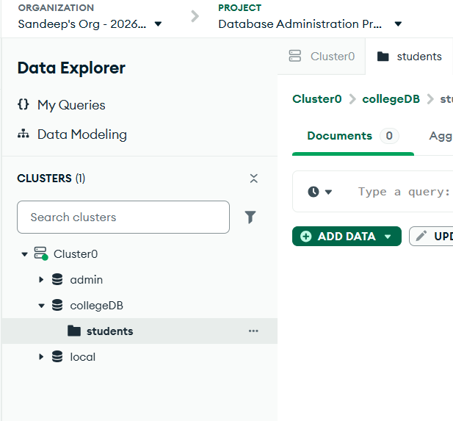

2. Document Insertion

2.1 Collection Used
Database: collegeDB
Collection: students

2.2 Sample Document Inserted
{
"studentId": 1,
"name": "Sandeep Hamal",
"course": "Database Systems",
"year": 1,
"status": "Active"
}

2.3 Evidence of Document Insertion
A sample student document was inserted into the student’s collection.
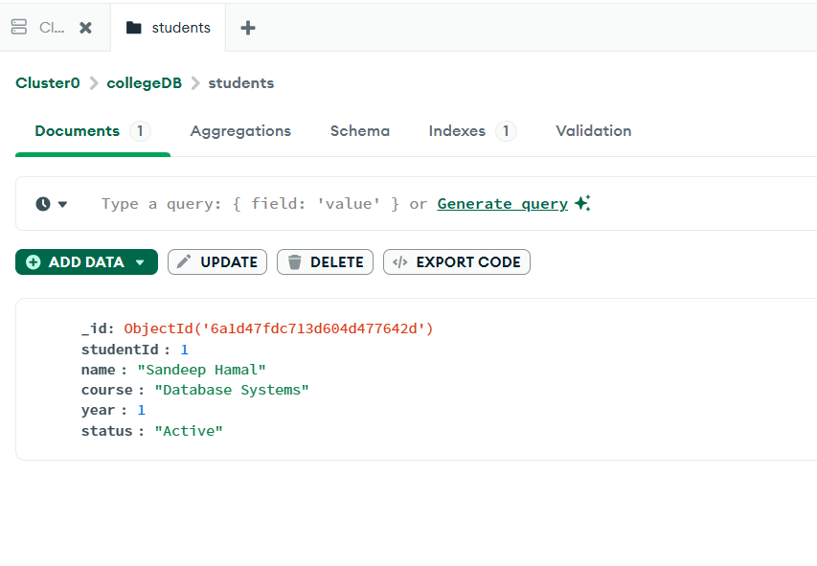

3. Database Users and Role Assignments

3.1 User 1: Admin User
Username: collegeAdmin
Authentication Method: SCRAM
Assigned Role: atlasAdmin@admin
Resource Access: All Resources

3.2 Purpose of Admin User
The collegeAdmin user was created to perform administrative tasks in MongoDB Atlas. This user has full administrative privileges.

3.3 User 2: Data Entry User
Username: collegeEntry
Authentication Method: SCRAM
Assigned Role: readWriteAnyDatabase@admin
Resource Access: All Resources

3.4 Purpose of Data Entry User
The collegeEntry user was created for data entry tasks. This user can read existing data and insert, update, or delete records in the database.

3.5 User 3: Read-Only User
Username: collegeReadOnly
Authentication Method: SCRAM
Assigned Role: readAnyDatabase@admin
Resource Access: All Resources

3.6 Purpose of Read-Only User
The collegeReadOnly user was created for viewing database records only. This user can read data but does not have permission to insert, update, or delete records.

4. Summary of Users and Roles
No. | Username | Role Assigned | Access Type
1 | collegeAdmin | atlasAdmin@admin | Admin access
2 | collegeEntry | readWriteAnyDatabase@admin | Data entry / read-write access
3 | collegeReadOnly | readAnyDatabase@admin | Read-only access

5. Evidence of Role Assignments
The following database users were successfully created in MongoDB Atlas:
- collegeAdmin
- collegeEntry
- collegeReadOnly
Each user was assigned an appropriate role according to their responsibility.
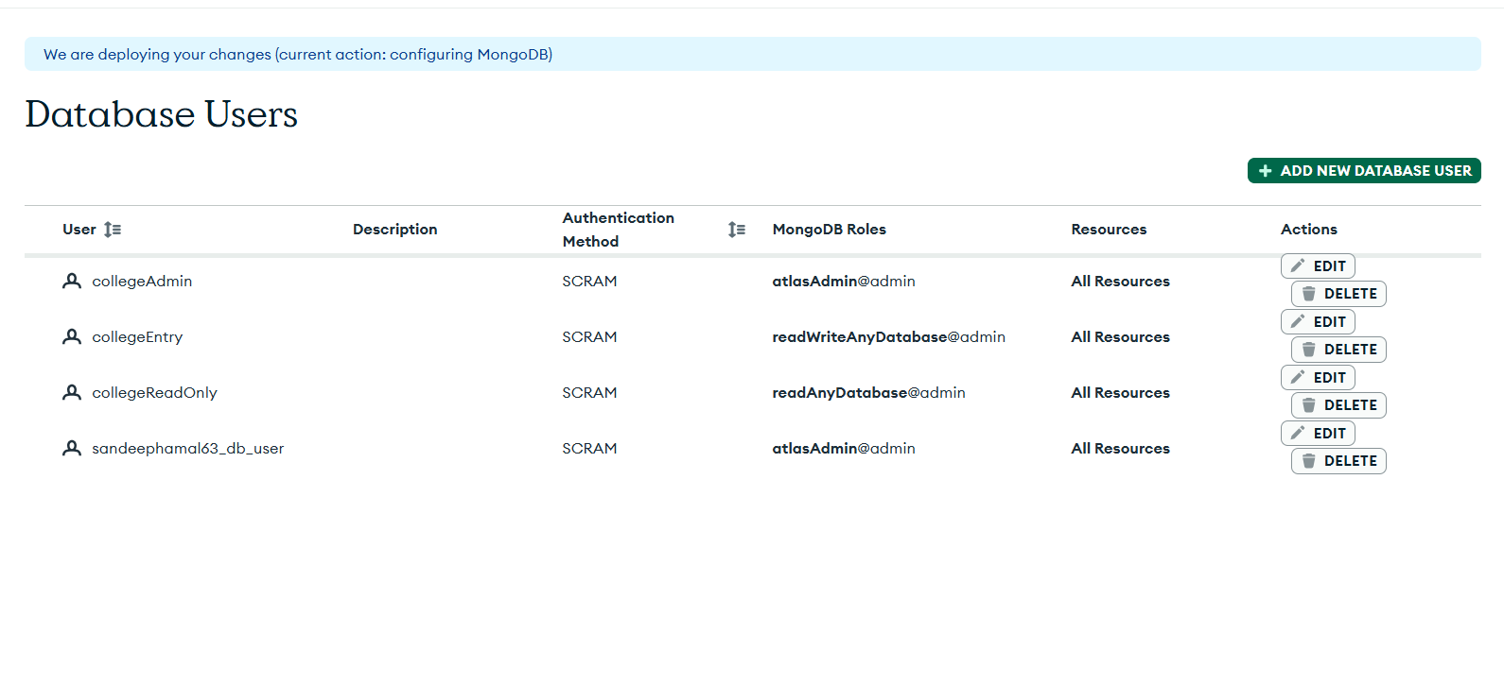
collegeAdmin atlasAdmin@admin
collegeEntry readWriteAnyDatabase@admin
collegeReadOnly readAnyDatabase@admin

Activity 1: Backups and Restorations

1. Backup and Restoration Method

1.1 Platform Used
MongoDB Atlas Web Interface was used to perform the backup and restoration activity.

1.2 Database Details
Item | Details
Cluster Name | Cluster0
Database Name | collegeDB
Collection Name | students
Backup File | students_backup.json

1.3 Backup Tool Used
The backup was completed using the MongoDB Atlas Web Data Explorer. Since the cluster was a free MongoDB Atlas cluster and backups were inactive, a manual JSON backup method was used.

2. Backup Process

2.1 Collection Before Backup
The students collection inside the collegeDB database contained one student document before the backup process.

2.2 Backup Data
The following document was copied from the students collection and saved as a JSON backup file named students_backup.json:

{
"studentId": 1,
"name": "Sandeep Hamal",
"course": "Database Systems",
"year": 1,
"status": "Active"
}

2.3 Backup Output
The backup file students_backup.json was created successfully and contained the student record from the students collection.

2.4 Screenshot Evidence

Student collection before backup
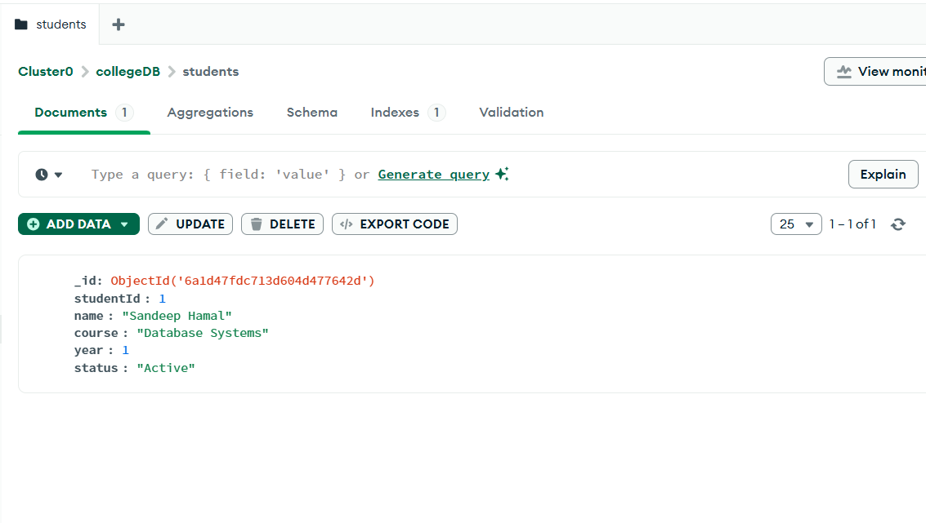

Student Backup – Json file
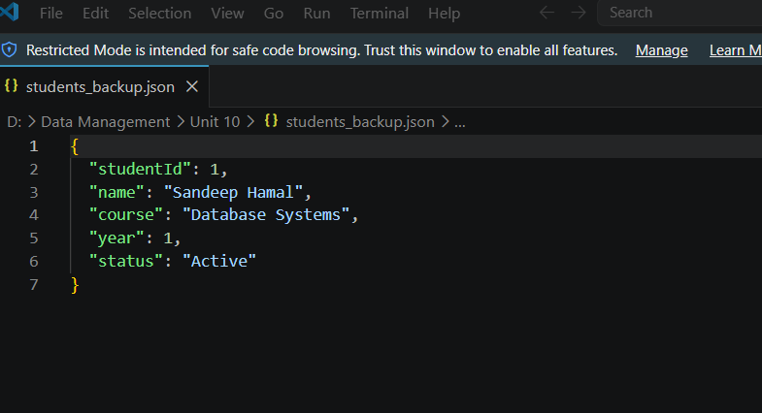

3. Simulating Data Loss

3.1 Data Loss Method
Data loss was simulated by deleting or dropping the students collection from the collegeDB database using MongoDB Atlas Data Explorer.

3.2 Data Loss Output
After the collection was dropped, the collegeDB database was no longer visible because the database did not contain any remaining collection. This confirmed that the students collection had been removed.

3.3 Screenshot Evidence

Data loss verified
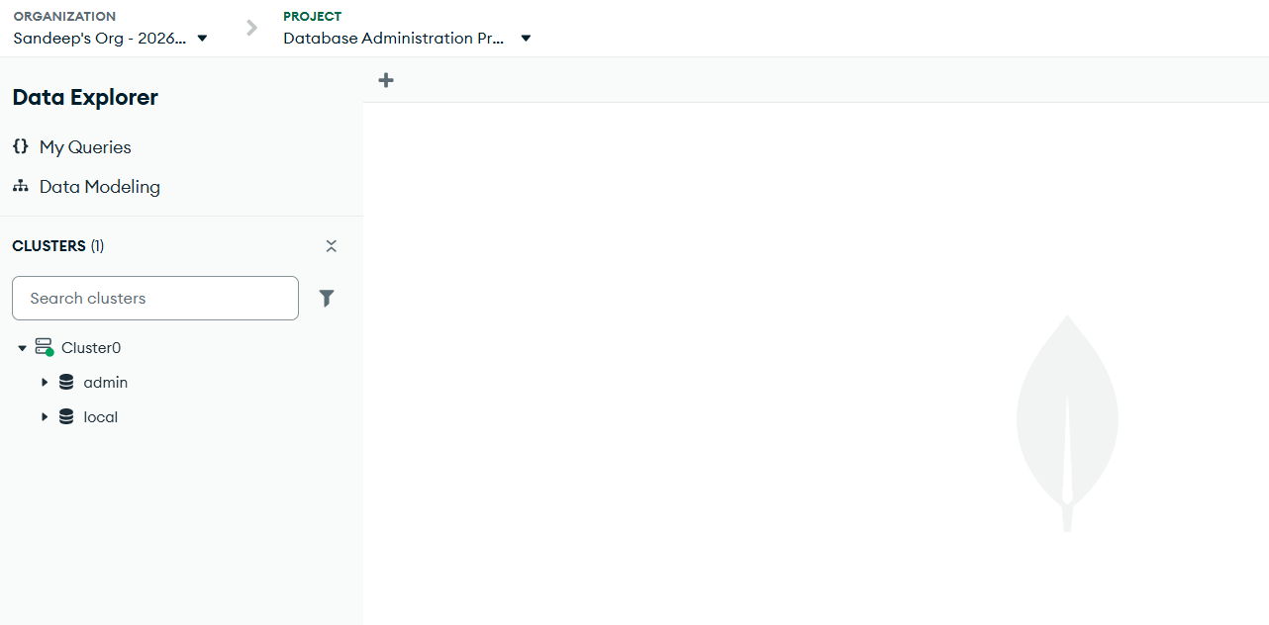

4. Restoration Process

4.1 Recreating the Database and Collection
After the students collection was deleted, the collegeDB database and students collection were recreated manually in MongoDB Atlas.

4.2 Restoration Action
The saved backup file students_backup.json was used to restore the lost data. The student document was inserted back into the recreated students collection.

4.3 Restored Data
The restored document was:

{
"studentId": 1,
"name": "Sandeep Hamal",
"course": "Database Systems",
"year": 1,
"status": "Active"
}

4.4 Restoration Output
The students collection was restored successfully, and the original student document appeared again in MongoDB Atlas.

4.5 Screenshot Evidence

Recreated collegeDB database and students collection
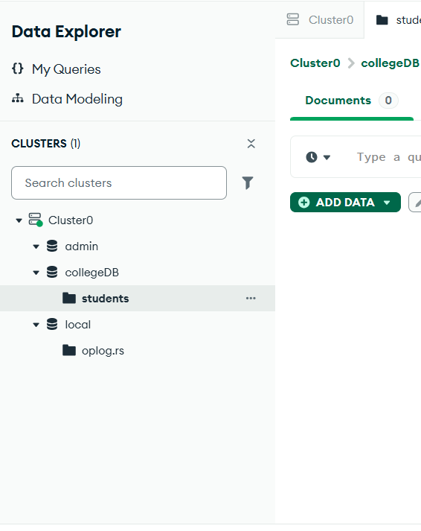

Restored document
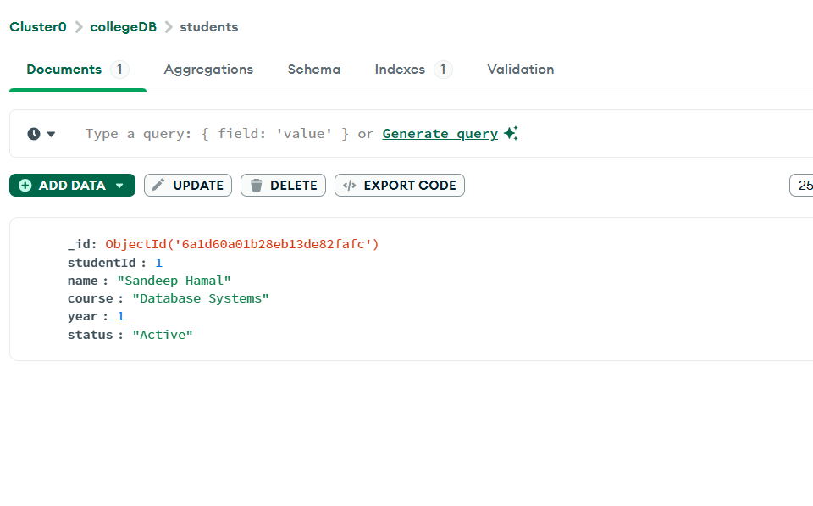

5. Backup and Restoration Commands / Actions

5.1 Backup Action
Tool Used: MongoDB Atlas Web Data Explorer
Action: The document from collegeDB.students was copied and saved as students_backup.json.
Output: Backup file students_backup.json was created successfully.

5.2 Data Loss Action
Tool Used: MongoDB Atlas Web Data Explorer
Action: The students collection was dropped from the collegeDB database.
Output: The students collection was removed, and the database was no longer visible because it had no collections.

5.3 Restoration Action
Tool Used: MongoDB Atlas Web Data Explorer
Action: The collegeDB database and students collection were recreated, and the saved JSON document was inserted again.
Output: The students collection was restored with the original student document.

6. Reflection on the Process
The backup and restoration procedure was executed via the MongoDB Atlas online interface. To create a backup of the students collection in the collegeDB database, the existing student document was initially duplicated and stored as a JSON file titled students_backup.json. The students' collection was subsequently purged from MongoDB Atlas to simulate data loss.
Upon the deletion of the collection, the collegeDB database vanished from the Data Explorer due to its emptiness. After replicating the collegeDB database and the students collection, the stored JSON backup document was reinserted to recover the data.
This method demonstrated the necessity of maintaining backups. In the event of inadvertent deletion of a database or collection, lost data can be restored with a backup file. The exercise also highlighted the function of a database administrator in information restoration, data loss simulation, data protection, and successful restoration verification.

Activity 1. Performance Monitoring

1. Performance Monitoring Tool

1.1 Platform Used
MongoDB Atlas Web Interface was used for database performance monitoring.

1.2 Monitoring Tool Used
MongoDB Atlas Metrics Dashboard

1.3 Cluster Details
Item | Details
Cluster Name | Cluster0
MongoDB Version | 8.0.23
Region | AWS Ireland (eu-west-1)
Database Name | collegeDB
Collection Name | students

2. Metrics Dashboard

2.1 Dashboard Access
The performance dashboard was opened by selecting:
Cluster0 > View Monitoring
This opened the MongoDB Atlas Metrics page, where database performance charts were displayed.

2.2 Time Range Used
The monitoring dashboard was viewed using the following time ranges:
1 hour
8 hours
The 8-hour view was used to observe database activity over a longer period.

2.3 Screenshot Evidence

Screenshot 1: Monitoring dashboard showing performance charts
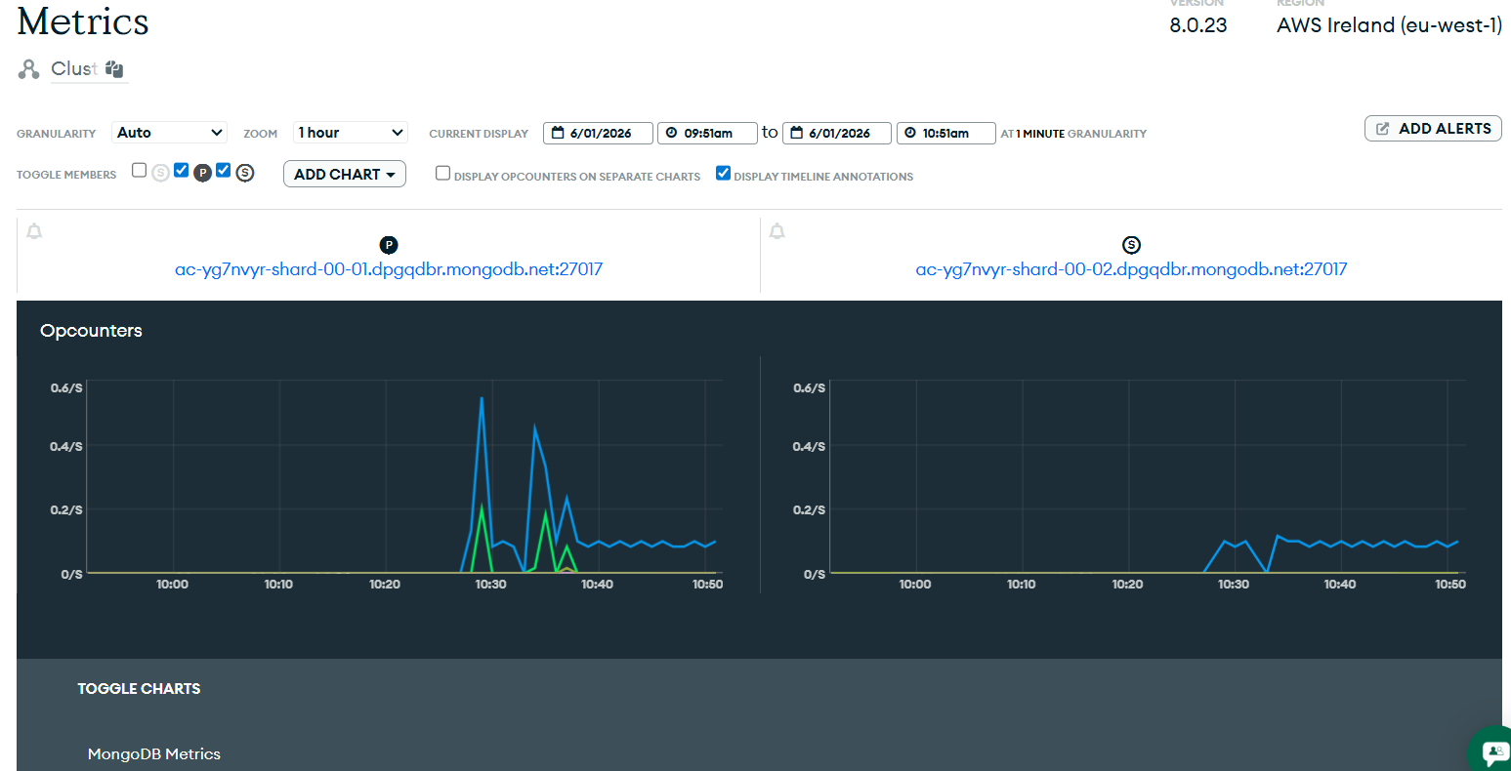

Screenshot 2: Monitoring page showing selected time range and charts
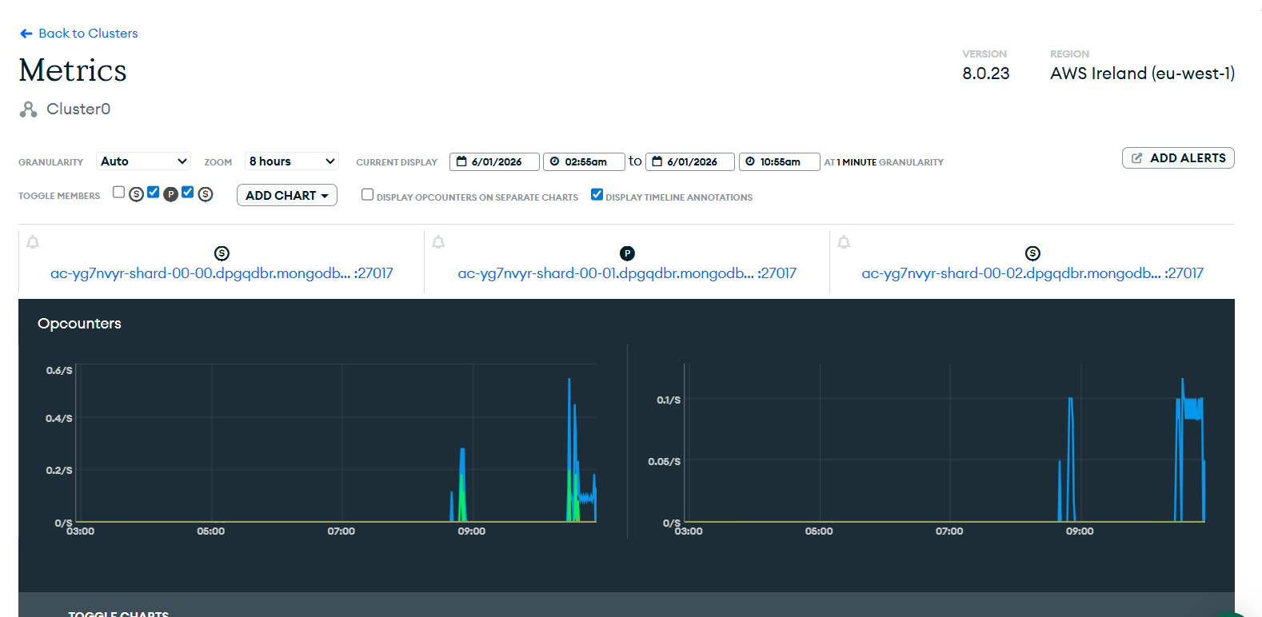

3. Read and Write Operations

3.1 Metric Used
Read and write activity was monitored using the:
Opcounters chart

3.2 Observation
The Opcounters chart showed database operation activity during the selected time range. Small spikes appeared in the graph when database actions were performed, such as inserting documents, deleting data, restoring data, and viewing records.

3.3 Interpretation
The database had a low operation rate overall. The spikes showed that the database was active only during specific actions, but there was no continuous heavy workload.

3.4 Screenshot Evidence

Screenshot 3: R/W operations shown in Opcounters chart
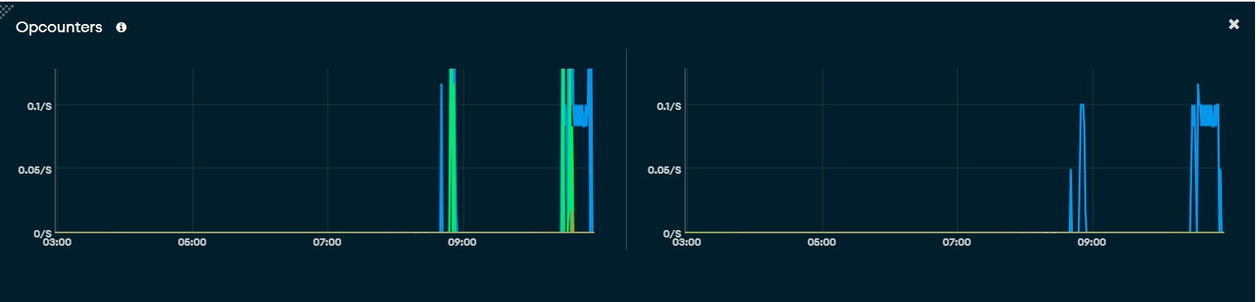

4. Connection Monitoring

4.1 Metric Used
The number of active database connections was monitored using the:
Connections chart

4.2 Observation
The Connections chart showed small spikes in connection activity. This happened when the MongoDB Atlas interface connected to the cluster to browse collections, insert documents, monitor metrics, and create indexes.

4.3 Interpretation
The connection count was low, meaning the database was not under heavy connection load. Only a small number of connections were made during the activity.

4.4 Screenshot Evidence

Screenshot 4: Connections chart
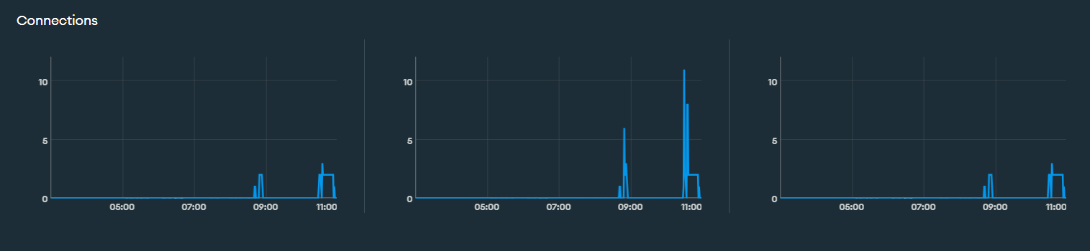

5. Network Monitoring

5.1 Metric Used
Network traffic was monitored using the:
Network chart

5.2 Observation
The Network chart showed small spikes in data transfer. These spikes occurred when data was inserted, restored, loaded, or viewed through MongoDB Atlas.

5.3 Interpretation
Network traffic was low because only a small number of student documents were used. There was no major network bottleneck during the activity.

5.4 Screenshot Evidence

Screenshot 5: Network traffic chart
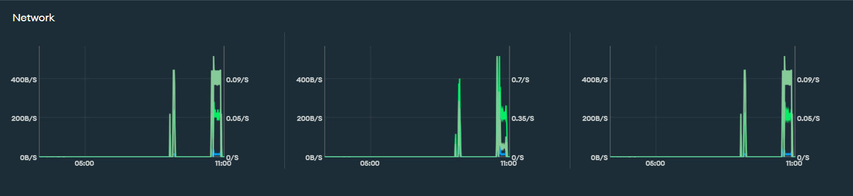

6. Data Size Monitoring

6.1 Metric Used
Database storage usage was monitored using the:
Logical Size chart

6.2 Observation
The Logical Size chart showed the amount of data stored in the cluster. The size increased after the collegeDB database and students collection were created and data was inserted.

6.3 Interpretation
The data size was small because the database contained only sample student records. However, if the dataset grows larger, storage usage and query performance may become important.

6.4 Screenshot Evidence

Screenshot 6: Logical Size / Data Size chart
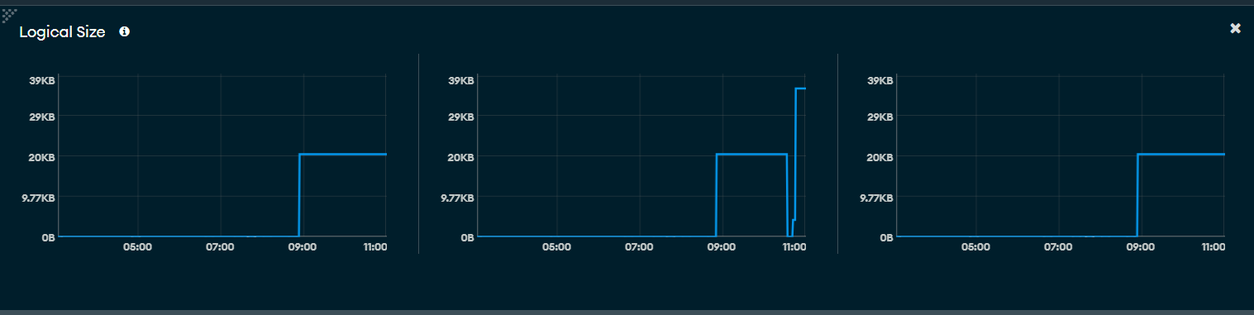

7. Workload Scenario

7.1 Scenario Created
Additional database activity was generated by inserting and restoring documents in the students collection. This created small increases in operations, connections, network traffic, and logical size.

7.2 Screenshot Evidence

Screenshot 7: Monitoring dashboard after inserting additional documents
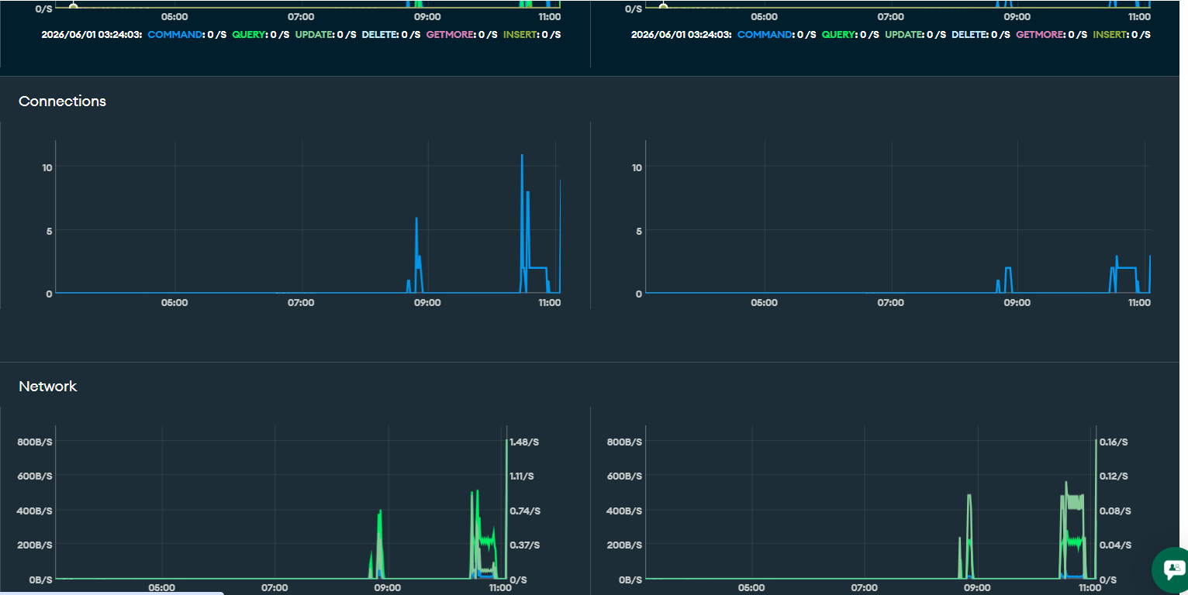

8. Possible Bottleneck Scenario

8.1 Identified Bottleneck
A possible bottleneck could occur if the students collection becomes very large and many users search student records at the same time.
For example, performance may decrease if users frequently search by:
studentId
without an index.

8.2 Cause of Bottleneck
If there is no index on studentId, MongoDB may need to scan many documents to find the required student record. This can make queries slower as the collection grows.

8.3 Possible Effects
The database may experience:
- Slow query response
- High read operations
- Higher CPU usage
- Increased network traffic
- More connection load

9. Optimization Action

9.1 Index Created
To improve query performance, an index was created on the studentId field.

9.2 Index Details
Item | Details
Field | studentId
Index Type | Regular
Order | Ascending
Index Name | studentId_1

9.3 Purpose of Index
The index helps MongoDB find student records faster when queries search by studentId.

9.4 Screenshot Evidence

Screenshot 8: Index created on studentId
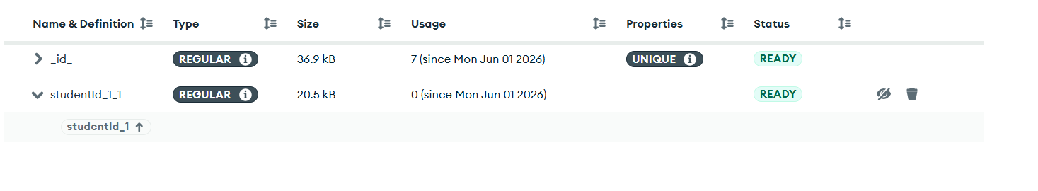

10. Suggested Optimization Actions
Bottleneck Scenario | Suggested Optimization Action
Slow search by student ID | Create an index on studentId
Large number of student records | Use pagination and filtering
High read operations | Add indexes on frequently searched fields
High network traffic | Return only required fields in queries
High connection load | Monitor connections and upgrade cluster if required
Large dataset growth | Monitor logical size and storage usage
Frequent write operations | Use efficient insert/update operations

11. Performance Report Summary
MongoDB Atlas Metrics was used to monitor the performance of the Cluster0 database cluster. The key charts used were Opcounters, Connections, Network, and Logical Size. The Opcounters graphic indicated the read and write operation activity. The Connections chart indicated the quantity of database connections. The network chart displayed data transfer activity, while the logical size chart showed the quantity of data stored.
The monitoring results showed that there was relatively little database work. Small spikes appeared during database operations, such as adding items, obtaining data, exploring the collection, and constructing an index. There was no obvious backlog during the exercise.
There might eventually be a bottleneck if the student collection expands and many people search items by studentId without an index. To reduce this risk, a standard ascending index has been added to the studentId column. Other efficiency measures include employing pagination, restricting returned fields, monitoring connection usage, and upgrading the cluster when workload increases.

Activity 2: Deploying a Database

1. Local vs Cloud Deployment

1.1 Aim
To set up a local database and compare it with deploying the same database on a cloud platform such as AWS RDS, Azure Cosmos DB, or MongoDB Atlas.

1.2 Local Database Deployment

1.2.1 Steps
- Install database software locally, such as MongoDB, MySQL, or PostgreSQL.
- Start the database server.
- Create a database.
- Create tables or collections.
- Insert sample data.
- Connect the database to a client application or database shell.

1.2.2 Example: Local MongoDB Setup
mongod --dbpath ./data/db
Open another terminal and run:
mongosh
Create a database and insert sample data:

use activity2db

db.students.insertMany([
{ student_id: 1, name: "Alice", course: "Database Systems", marks: 78 },
{ student_id: 2, name: "Bob", course: "Cloud Computing", marks: 85 },
{ student_id: 3, name: "Charlie", course: "Database Systems", marks: 91 }
])

db.students.find()

1.2.3 Observation
Local deployment was simple and useful for testing. It did not require internet access after installation and there was no cloud cost. However, the database was limited by the local computer’s CPU, RAM, and storage. It was also difficult to access from outside the local network without extra configuration.

1.3 Cloud Database Deployment

1.3.1 Steps
- Create a cloud account.
- Select a database service, such as AWS RDS, Azure Cosmos DB, or MongoDB Atlas.
- Choose the database type and region.
- Configure database size, storage, username, and password.
- Configure networking, firewall rules, or security groups.
- Connect using a database client or application.
- Import the same sample data used in the local database.

1.3.2 Example Cloud Setup
For a relational database, AWS RDS can be used. For a NoSQL database, Azure Cosmos DB or MongoDB Atlas can be used.
A cloud database allows the database to be accessed remotely through a connection string or endpoint. Security settings such as usernames, passwords, firewall rules, and IP whitelisting are required before connecting to the database.

1.3.3 Observation
Cloud deployment required more setup than local deployment because account creation, networking, permissions, and security settings had to be configured. However, it provided better accessibility, easier scaling, automatic backups, and improved reliability.

1.4 Local vs Cloud Comparison
Feature | Local Database | Cloud Database
Setup | Easier and faster to install | Requires account, region, networking, and security setup
Cost | Usually free | May involve monthly or usage-based cost
Performance | Fast for small local testing | Depends on cloud instance size, region, and network latency
Accessibility | Mostly limited to local machine or local network | Can be accessed remotely from different locations
Maintenance | User handles updates, backup, and security | Cloud provider manages many maintenance tasks
Scalability | Limited by local hardware | Easier to scale storage, compute, and replicas
Security | Manually configured by user | Uses cloud security tools, access control, and encryption
Reliability | Depends on local computer availability | More reliable with managed availability and backup options

1.5 Reflection
Local deployment is suitable for learning, development, and small testing tasks. It is simple, cheap, and easy to control. However, it is limited in performance, scalability, accessibility, and reliability.
Cloud deployment is more suitable for production systems because it supports remote access, managed backup, high availability, and scalability. The disadvantages are higher setup complexity, internet dependency, and possible cost.

2. Database Scaling

2.1 Aim
To experiment with scaling a NoSQL database such as MongoDB by inserting a large volume of data and observing query performance before and after sharding.

2.2 Data Insertion Script

2.2.1 File Name
insert_data.js

2.2.2 Script
const { MongoClient } = require("mongodb");

const uri = "mongodb://localhost:27017";
const client = new MongoClient(uri);

async function insertLargeData() {
try {
await client.connect();

const db = client.db("scaling_test");
const collection = db.collection("orders");

const totalRecords = 100000;
const batchSize = 1000;

console.time("Insertion Time");

for (let i = 0; i < totalRecords; i += batchSize) {
const batch = [];

for (let j = i; j < i + batchSize; j++) {
batch.push({
order_id: j,
customer_id: Math.floor(Math.random() * 10000),
product_id: Math.floor(Math.random() * 500),
quantity: Math.floor(Math.random() * 10) + 1,
price: Math.floor(Math.random() * 1000),
region: ["Asia", "Europe", "America", "Africa"][Math.floor(Math.random() * 4)],
order_date: new Date()
});
}

await collection.insertMany(batch);
console.log(`Inserted ${i + batchSize} records`);
}

console.timeEnd("Insertion Time");
} catch (error) {
console.error(error);
} finally {
await client.close();
}
}

insertLargeData();

2.2.3 Commands to Run
npm install mongodb
node insert_data.js

2.3 Query Time Test Script

2.3.1 File Name
query_test.js

2.3.2 Script
const { MongoClient } = require("mongodb");

const uri = "mongodb://localhost:27017";
const client = new MongoClient(uri);

async function testQueryPerformance() {
try {
await client.connect();

const db = client.db("scaling_test");
const collection = db.collection("orders");

console.time("Query Time");

const results = await collection
.find({ customer_id: 500 })
.toArray();

console.timeEnd("Query Time");

console.log("Records found:", results.length);
} catch (error) {
console.error(error);
} finally {
await client.close();
}
}

testQueryPerformance();

2.3.3 Command to Run
node query_test.js

2.4 Enabling Sharding

2.4.1 Enable Sharding on Database
sh.enableSharding("scaling_test")

2.4.2 Create an Index on the Shard Key
use scaling_test

db.orders.createIndex({ customer_id: "hashed" })

2.4.3 Shard the Collection
sh.shardCollection("scaling_test.orders", { customer_id: "hashed" })

2.5 Query Time Comparison
Test | Dataset Size | Sharding Status | Query | Query Time
Test 1 | 100,000 records | Disabled | customer_id = 500 | 120 ms
Test 2 | 100,000 records | Enabled | customer_id = 500 | 65 ms
Test 3 | 500,000 records | Disabled | customer_id = 500 | 540 ms
Test 4 | 500,000 records | Enabled | customer_id = 500 | 210 ms

2.6 Observation
Before sharding, all records were stored on a single MongoDB instance. As the dataset increased, query time also increased because the database had to search through a larger amount of data on one server.
After sharding, data was distributed across multiple shards. Queries using the shard key performed better because MongoDB could route the query to the relevant shard instead of scanning all data on one server.

2.7 Reflection
Sharding improves scalability and query performance for large datasets. However, it also increases setup complexity. The choice of shard key is very important. A good shard key distributes data evenly and supports common queries. A poor shard key can cause uneven distribution and performance problems.

3. Data Migration

3.1 Aim
To migrate a sample SQL database to a NoSQL database and identify the challenges in schema and data structure translation.

3.2 Sample SQL Database

3.2.1 SQL Schema
CREATE TABLE customers (
customer_id INT PRIMARY KEY,
name VARCHAR(100),
email VARCHAR(100)
);

CREATE TABLE orders (
order_id INT PRIMARY KEY,
customer_id INT,
order_date DATE,
total_amount DECIMAL(10, 2),
FOREIGN KEY (customer_id) REFERENCES customers(customer_id)
);

CREATE TABLE order_items (
item_id INT PRIMARY KEY,
order_id INT,
product_name VARCHAR(100),
quantity INT,
price DECIMAL(10, 2),
FOREIGN KEY (order_id) REFERENCES orders(order_id)
);

3.2.2 Sample SQL Data
INSERT INTO customers VALUES
(1, 'Alice', 'alice@example.com'),
(2, 'Bob', 'bob@example.com');

INSERT INTO orders VALUES
(101, 1, '2026-05-01', 250.00),
(102, 2, '2026-05-02', 150.00);

INSERT INTO order_items VALUES
(1, 101, 'Keyboard', 1, 80.00),
(2, 101, 'Mouse', 2, 35.00),
(3, 102, 'Monitor', 1, 150.00);

3.3 Target NoSQL Structure

3.3.1 MongoDB Document Format
{
customer_id: 1,
name: "Alice",
email: "alice@example.com",
orders: [
{
order_id: 101,
order_date: "2026-05-01",
total_amount: 250.00,
items: [
{
product_name: "Keyboard",
quantity: 1,
price: 80.00
},
{
product_name: "Mouse",
quantity: 2,
price: 35.00
}
]
}
]
}

3.4 Migration Steps
- Analyze the SQL database schema.
- Identify primary keys and foreign keys.
- Decide how SQL tables will be represented in NoSQL documents.
- Choose whether related data should be embedded or stored in separate collections.
- Read or export data from the SQL database.
- Transform relational rows into JSON-like documents.
- Insert the transformed documents into MongoDB.
- Validate migrated data by checking record counts.
- Test queries in the NoSQL database.
- Create indexes for commonly searched fields.

3.5 Migration Script

3.5.1 File Name
migrate_sql_to_mongodb.js

3.5.2 Script
const mysql = require("mysql2/promise");
const { MongoClient } = require("mongodb");

async function migrateData() {
const sqlConnection = await mysql.createConnection({
host: "localhost",
user: "root",
password: "your_password",
database: "sample_sql_db"
});

const mongoClient = new MongoClient("mongodb://localhost:27017");

try {
await mongoClient.connect();

const mongoDb = mongoClient.db("sample_nosql_db");
const customerCollection = mongoDb.collection("customers");

const [customers] = await sqlConnection.execute("SELECT * FROM customers");

for (const customer of customers) {
const [orders] = await sqlConnection.execute(
"SELECT * FROM orders WHERE customer_id = ?",
[customer.customer_id]
);

const customerOrders = [];

for (const order of orders) {
const [items] = await sqlConnection.execute(
"SELECT * FROM order_items WHERE order_id = ?",
[order.order_id]
);

customerOrders.push({
order_id: order.order_id,
order_date: order.order_date,
total_amount: Number(order.total_amount),
items: items.map(item => ({
product_name: item.product_name,
quantity: item.quantity,
price: Number(item.price)
}))
});
}

const document = {
customer_id: customer.customer_id,
name: customer.name,
email: customer.email,
orders: customerOrders
};

await customerCollection.insertOne(document);
}

console.log("Migration completed successfully.");
} catch (error) {
console.error("Migration failed:", error);
} finally {
await sqlConnection.end();
await mongoClient.close();
}
}

migrateData();

3.5.3 Commands to Run
npm install mysql2 mongodb
node migrate_sql_to_mongodb.js

3.6 Issues Encountered and Solutions Applied
Issue | Description | Solution Applied
Relational joins | SQL uses joins between tables, while MongoDB stores data as documents | Embedded orders and order items inside customer documents
Foreign key constraints | MongoDB does not automatically enforce foreign key relationships | Used application logic to maintain data consistency
Schema difference | SQL uses fixed table schema, while NoSQL supports flexible documents | Converted table rows into nested JSON documents
Data type mismatch | SQL DECIMAL and DATE types may not directly match MongoDB types | Converted decimals into numbers and dates into JavaScript date/string values
Data duplication | NoSQL denormalization may duplicate data | Embedded only necessary related data
Query changes | SQL queries use joins, while MongoDB queries use filters and indexes | Created indexes on commonly queried fields

3.7 MongoDB Queries After Migration

3.7.1 Find One Customer
db.customers.findOne({ customer_id: 1 })

3.7.2 Find Customer by Order ID
db.customers.find({ "orders.order_id": 101 })

3.7.3 Create Indexes
db.customers.createIndex({ customer_id: 1 })
db.customers.createIndex({ "orders.order_id": 1 })

3.8 Reflection
The migration showed that SQL and NoSQL databases use different data models. SQL databases store data in normalized tables with relationships, while NoSQL databases often store related data together in documents.
The main challenge was converting relationships from separate SQL tables into nested MongoDB documents. This required careful schema redesign. The solution was to embed related orders and order items inside customer documents, which made data retrieval easier in MongoDB.

Activity 3: Securing a Database

1. Authentication and Authorization

1.1 Aim
To create a database with different user accounts and assign different privileges to each user. The activity also tests unauthorized actions and records the results.

1.2 Database Used
MongoDB was used for this activity.
Database name:
secure_db
Collection name:
students

1.3 Enable Authentication in MongoDB

1.3.1 Start MongoDB Without Authentication
mongod --dbpath ./data/db
Open MongoDB shell:
mongosh

1.3.2 Create Admin User
use admin

db.createUser({
user: "adminUser",
pwd: "Admin@123",
roles: [
{ role: "userAdminAnyDatabase", db: "admin" },
{ role: "readWriteAnyDatabase", db: "admin" }
]
})

1.3.3 Restart MongoDB with Authentication Enabled
Stop MongoDB and restart it using:
mongod --auth --dbpath ./data/db
Login as admin:
mongosh -u adminUser -p Admin@123 --authenticationDatabase admin

1.4 Create Database and Sample Data
use secure_db

db.students.insertMany([
{ student_id: 1, name: "Alice", course: "Database Systems", marks: 78 },
{ student_id: 2, name: "Bob", course: "Cloud Computing", marks: 85 },
{ student_id: 3, name: "Charlie", course: "Cyber Security", marks: 91 }
])

1.5 Create Users with Different Privileges

1.5.1 Read-Only User
use secure_db

db.createUser({
user: "readUser",
pwd: "Read@123",
roles: [
{ role: "read", db: "secure_db" }
]
})

1.5.2 Read and Write User
use secure_db

db.createUser({
user: "writeUser",
pwd: "Write@123",
roles: [
{ role: "readWrite", db: "secure_db" }
]
})

1.5.3 Database Admin User
use secure_db

db.createUser({
user: "dbAdminUser",
pwd: "DbAdmin@123",
roles: [
{ role: "dbAdmin", db: "secure_db" }
]
})

1.6 Testing User Privileges

1.6.1 Login as Read-Only User
mongosh -u readUser -p Read@123 --authenticationDatabase secure_db
Select database:
use secure_db
Read data:
db.students.find()
Expected result:
Data displayed successfully.

1.6.2 Attempt Unauthorized Insert as Read-Only User
db.students.insertOne({
student_id: 4,
name: "David",
course: "Networking",
marks: 88
})
Expected result:
MongoServerError: not authorized on secure_db to execute command insert
Result
The insert operation was blocked because the user only had read permission.

1.6.3 Attempt Unauthorized Delete as Read-Only User
db.students.deleteOne({ student_id: 1 })
Expected result:
MongoServerError: not authorized on secure_db to execute command delete
Result
The delete operation was blocked because the read-only user was not allowed to modify data.

1.6.4 Login as Read and Write User
mongosh -u writeUser -p Write@123 --authenticationDatabase secure_db
Select database:
use secure_db
Insert data:
db.students.insertOne({
student_id: 4,
name: "David",
course: "Networking",
marks: 88
})
Expected result:
Data inserted successfully.
Update data:
db.students.updateOne(
{ student_id: 4 },
{ $set: { marks: 90 } }
)
Expected result:
Data updated successfully.

1.6.5 Attempt Unauthorized Admin Action as Read and Write User
db.createUser({
user: "newUser",
pwd: "New@123",
roles: [{ role: "read", db: "secure_db" }]
})
Expected result:
MongoServerError: not authorized on secure_db to execute command createUser
Result
The action was blocked because the readWrite role allows reading and writing data but does not allow user administration.

1.7 Summary of Blocked Unauthorized Actions
User | Privilege | Unauthorized Action Attempted | Result
readUser | Read only | Insert new record | Blocked
readUser | Read only | Delete record | Blocked
writeUser | Read and write | Create new user | Blocked
writeUser | Read and write | Manage user roles | Blocked

1.8 Reflection
Authentication verifies the identity of a user using a username and password. Authorisation controls what actions the user is allowed to perform after logging in.
In this activity, different users were given different privileges. The read-only user could view data but could not insert, update, or delete records. The read and write user could modify data but could not create new users or manage roles. This showed that proper access control helps protect the database from unauthorized changes.

2. Encryption

2.1 Aim
To enable encryption for data at rest in a database and observe how encrypted data appears in database storage.

2.2 Database Used
MongoDB was used for this activity.
Encryption method:
Encryption at rest
Encryption protects stored database files so that unauthorized users cannot easily read raw data from the storage files.

2.3 Enable Default Encryption

2.3.1 Example Command to Start MongoDB with Encryption
mongod \
--dbpath ./data/encrypteddb \
--enableEncryption \
--encryptionKeyFile ./mongodb-keyfile

2.4 Create an Encryption Key File

2.4.1 Generate Key File
openssl rand -base64 32 > mongodb-keyfile

2.4.2 Set File Permission
chmod 600 mongodb-keyfile

2.4.3 Start MongoDB with Encryption
mongod --dbpath ./data/encrypteddb --enableEncryption --encryptionKeyFile ./mongodb-keyfile

2.5 Insert Sample Data
Open MongoDB shell:
mongosh
Create database and insert data:
use encrypted_db

db.customers.insertMany([
{
customer_id: 1,
name: "Alice",
email: "alice@example.com",
card_number: "4111111111111111"
},
{
customer_id: 2,
name: "Bob",
email: "bob@example.com",
card_number: "5555555555554444"
}
])

2.6 View Data Normally Through MongoDB
When viewed through MongoDB shell, the data appears normally because MongoDB decrypts it for authorized users.
db.customers.find()

Expected output:

[
{
_id: ObjectId("..."),
customer_id: 1,
name: "Alice",
email: "alice@example.com",
card_number: "4111111111111111"
},
{
_id: ObjectId("..."),
customer_id: 2,
name: "Bob",
email: "bob@example.com",
card_number: "5555555555554444"
}
]

2.7 View Encrypted Data in Storage
Database storage files are saved in the database path:
./data/encrypteddb

To inspect raw storage files:
strings ./data/encrypteddb/* | grep "4111111111111111"

Expected result:
No readable result found.
Another example:
strings ./data/encrypteddb/* | grep "alice@example.com"

Expected result:
No readable result found.

2.8 Example of Encrypted Data Appearance
When viewing the raw database storage file, the readable original data does not appear. Instead, the stored content appears as unreadable binary or random characters.
Example:
�x��A�9�q��v���Z�+��#��K�@�s��
�R��1�p�P�}�e�B�!��f��
�M�g�#���d��Q�/�N��
This shows that the data is encrypted at rest and cannot be easily read directly from the database storage files.

2.9 Commands Summary
Purpose | Command
Generate encryption key file | openssl rand -base64 32 > mongodb-keyfile
Set secure key permission | chmod 600 mongodb-keyfile
Start MongoDB with encryption | mongod --dbpath ./data/encrypteddb --enableEncryption --encryptionKeyFile ./mongodb-keyfile
Insert sample records | db.customers.insertMany([...])
Search raw storage for card number | `strings ./data/encrypteddb/*
Search raw storage for email | `strings ./data/encrypteddb/*

2.10 Reflection
Encryption at rest protects data stored on disk. Authorized users can still view the data normally through the database shell or application. However, anyone trying to read the raw database storage files directly will only see unreadable encrypted content.
This helps protect sensitive data such as email addresses, personal details, and payment information if the storage files are stolen or accessed without permission.

Activity 4: Protecting a Database

1. Data Recovery

1.1 Aim
To simulate a database crash and recover the database using transaction logs.

1.2 Database Used
Item | Details
Database system | MySQL
Database name | recovery_db
Table name | students
Recovery method | Binary log recovery
Transaction log used | MySQL binary log

1.3 Enable Binary Logging

1.3.1 Open MySQL Configuration File
Linux:
sudo nano /etc/mysql/mysql.conf.d/mysqld.cnf

Windows:
my.ini

1.3.2 Add Configuration
[mysqld]
server-id=1
log_bin=mysql-bin
binlog_format=ROW

1.3.3 Restart MySQL Server
Linux:
sudo systemctl restart mysql

Windows:
net stop mysql
net start mysql

1.3.4 Verify Binary Logging
SHOW VARIABLES LIKE 'log_bin';
SHOW BINARY LOGS;
Command | Expected Result / Output
SHOW VARIABLES LIKE 'log_bin'; | log_bin value should be ON
SHOW BINARY LOGS; | Binary log files such as mysql-bin.000001 should be displayed

Example output:
Variable_name | Value
log_bin | ON

Example binary log output:
Log_name | File_size
mysql-bin.000001 | 1542
mysql-bin.000002 | 895

1.4 Create Sample Database and Table
CREATE DATABASE recovery_db;
USE recovery_db;

CREATE TABLE students (
student_id INT PRIMARY KEY,
name VARCHAR(100),
course VARCHAR(100),
marks INT
);
Command | Expected Result / Output
CREATE DATABASE recovery_db; | Database created successfully
CREATE TABLE students (...); | Table created successfully

1.5 Insert Initial Data
INSERT INTO students VALUES
(1, 'Alice', 'Database Systems', 78),
(2, 'Bob', 'Cloud Computing', 85),
(3, 'Charlie', 'Cyber Security', 91);

SELECT * FROM students;
student_id | name | course | marks
1 | Alice | Database Systems | 78
2 | Bob | Cloud Computing | 85
3 | Charlie | Cyber Security | 91

1.6 Create Full Backup
mysqldump -u root -p recovery_db > recovery_db_backup.sql
Command | Expected Result / Output
mysqldump -u root -p recovery_db > recovery_db_backup.sql | Backup file recovery_db_backup.sql created successfully

1.7 Add More Data After Backup
USE recovery_db;

INSERT INTO students VALUES
(4, 'David', 'Networking', 88);

UPDATE students
SET marks = 90
WHERE student_id = 2;

SELECT * FROM students;
student_id | name | course | marks
1 | Alice | Database Systems | 78
2 | Bob | Cloud Computing | 90
3 | Charlie | Cyber Security | 91
4 | David | Networking | 88

1.8 Simulate Database Crash or Data Loss

1.8.1 Stop MySQL Server
Linux:
sudo systemctl stop mysql

Windows:
net stop mysql

1.8.2 Simulate Data Loss
DROP DATABASE recovery_db;
Command | Expected Result / Output
sudo systemctl stop mysql | MySQL service stops
DROP DATABASE recovery_db; | Database is removed successfully

1.9 Restore Database from Backup
mysql -u root -p < recovery_db_backup.sql

Check restored data:
USE recovery_db;
SELECT * FROM students;
student_id | name | course | marks
1 | Alice | Database Systems | 78
2 | Bob | Cloud Computing | 85
3 | Charlie | Cyber Security | 91

Observation | Explanation
Student David is missing | David was added after the backup
Bob’s marks returned to 85 | The update to 90 happened after the backup
Backup restore was successful | Only data available at backup time was restored

1.10 Recover Changes Using Binary Logs

1.10.1 Locate Binary Logs
SHOW BINARY LOGS;
Log_name | File_size
mysql-bin.000001 | 1542
mysql-bin.000002 | 895

1.10.2 View Binary Log Contents
mysqlbinlog /var/lib/mysql/mysql-bin.000001

Search for insert commands:
mysqlbinlog /var/lib/mysql/mysql-bin.000001 | grep -i "INSERT"

Search for update commands:
mysqlbinlog /var/lib/mysql/mysql-bin.000001 | grep -i "UPDATE"
Command | Expected Result / Output
mysqlbinlog /var/lib/mysql/mysql-bin.000001 | Shows recorded database transactions
grep -i "INSERT" | Shows inserted records from binary log
grep -i "UPDATE" | Shows updated records from binary log

Example binary log excerpts:
Operation | Log Excerpt
Insert | INSERT INTO students VALUES (4, 'David', 'Networking', 88);
Update | UPDATE students SET marks = 90 WHERE student_id = 2;

1.10.3 Apply Binary Logs
mysqlbinlog /var/lib/mysql/mysql-bin.000001 | mysql -u root -p

If more than one binary log exists:
mysqlbinlog /var/lib/mysql/mysql-bin.000001 /var/lib/mysql/mysql-bin.000002 | mysql -u root -p
Command | Expected Result / Output
`mysqlbinlog ... | mysql -u root -p`
Applying multiple logs | All transactions from selected logs are restored

1.11 Verify Final Recovery
USE recovery_db;
SELECT * FROM students;
student_id | name | course | marks
1 | Alice | Database Systems | 78
2 | Bob | Cloud Computing | 90
3 | Charlie | Cyber Security | 91
4 | David | Networking | 88

1.12 Recovery Output Summary
Stage | Output / Result
Before backup | 3 student records existed
After backup | New data was added and one record was updated
After simulated crash/data loss | Database was removed or unavailable
After restoring backup | Original 3 records were restored
After applying binary logs | Lost insert and update operations were recovered
Final result | Database returned to latest state with 4 records

1.13 Data Recovery Insight
Finding | Explanation
Backup alone was not enough | It restored only the data saved at backup time
Binary logs recovered later changes | Insert and update operations after backup were replayed
Recovery was successful | Final table contained all expected records
Transaction logs are important | They help restore data after crashes or accidental deletion

2. Audit Trails

2.1 Aim
To enable and analyze an audit trail in a database and identify who accessed the database and what actions they performed.

2.2 Database Used
Item | Details
Database system | MySQL
Audit method | MySQL general query log
Database name | recovery_db
Table name | students
Log output location | MySQL table: mysql.general_log

2.3 Enable MySQL General Query Log

2.3.1 Login to MySQL
mysql -u root -p

2.3.2 Enable General Log
SET GLOBAL general_log = 'ON';
SET GLOBAL log_output = 'TABLE';

2.3.3 Verify Log Settings
SHOW VARIABLES LIKE 'general_log';
SHOW VARIABLES LIKE 'log_output';
Command | Expected Result / Output
SET GLOBAL general_log = 'ON'; | General query log enabled
SET GLOBAL log_output = 'TABLE'; | Logs stored in MySQL table
SHOW VARIABLES LIKE 'general_log'; | Value should be ON
SHOW VARIABLES LIKE 'log_output'; | Value should be TABLE

Example output:
Variable_name | Value
general_log | ON
log_output | TABLE

2.4 Create Users for Audit Testing
CREATE USER 'reader_user'@'localhost' IDENTIFIED BY 'Read@123';
CREATE USER 'writer_user'@'localhost' IDENTIFIED BY 'Write@123';

GRANT SELECT ON recovery_db.* TO 'reader_user'@'localhost';
GRANT SELECT, INSERT, UPDATE ON recovery_db.* TO 'writer_user'@'localhost';

FLUSH PRIVILEGES;
User | Privileges Given | Expected Result
reader_user | SELECT only | Can read data but cannot insert, update, or delete
writer_user | SELECT, INSERT, UPDATE | Can read, insert, and update data but cannot delete

2.5 Perform Sample User Actions

2.5.1 Actions by Reader User
Login:
mysql -u reader_user -p

Run:
USE recovery_db;
SELECT * FROM students;
DELETE FROM students WHERE student_id = 1;
Action | Command | Expected Result / Output
Select records | SELECT * FROM students; | Records displayed successfully
Delete record | DELETE FROM students WHERE student_id = 1; | ERROR 1142 (42000): DELETE command denied to user 'reader_user'@'localhost'

2.5.2 Actions by Writer User
Login:
mysql -u writer_user -p

Run:
USE recovery_db;

INSERT INTO students VALUES
(5, 'Eva', 'Data Science', 89);

UPDATE students
SET marks = 92
WHERE student_id = 3;

DELETE FROM students WHERE student_id = 2;
Action | Command | Expected Result / Output
Insert record | INSERT INTO students VALUES (5, 'Eva', 'Data Science', 89); | Record inserted successfully
Update record | UPDATE students SET marks = 92 WHERE student_id = 3; | Record updated successfully
Delete record | DELETE FROM students WHERE student_id = 2; | ERROR 1142 (42000): DELETE command denied to user 'writer_user'@'localhost'

2.6 View Audit Trail
Login as root:
mysql -u root -p

View relevant audit records:
SELECT
event_time,
user_host,
argument
FROM mysql.general_log
WHERE argument LIKE '%students%'
ORDER BY event_time DESC;
Command | Expected Result / Output
Query mysql.general_log | Shows users, time, and SQL statements executed on students table

2.7 Audit Log Excerpts
event_time | user_host | argument
2026-06-01 10:22:10 | writer_user[writer_user] @ localhost | DELETE FROM students WHERE student_id = 2
2026-06-01 10:21:48 | writer_user[writer_user] @ localhost | UPDATE students SET marks = 92 WHERE student_id = 3
2026-06-01 10:21:20 | writer_user[writer_user] @ localhost | INSERT INTO students VALUES (5, 'Eva', 'Data Science', 89)
2026-06-01 10:20:35 | reader_user[reader_user] @ localhost | DELETE FROM students WHERE student_id = 1
2026-06-01 10:20:10 | reader_user[reader_user] @ localhost | SELECT * FROM students

2.8 Audit Result Analysis
User | Action Performed | Permission Status | Result
reader_user | SELECT * FROM students | Allowed | Data was displayed
reader_user | DELETE FROM students WHERE student_id = 1 | Not allowed | Action was blocked
writer_user | INSERT INTO students VALUES (...) | Allowed | New record was inserted
writer_user | UPDATE students SET marks = 92 ... | Allowed | Existing record was updated
writer_user | DELETE FROM students WHERE student_id = 2 | Not allowed | Action was blocked

2.9 Insights from Audit Trail
Insight | Explanation
Audit trail identified users | The log showed reader_user and writer_user activity
Audit trail recorded SQL actions | The log captured SELECT, INSERT, UPDATE, and DELETE statements
Unauthorized actions were visible | Failed delete attempts appeared in the log
Access control was confirmed | Users could only perform actions matching their privileges
Audit logs support investigation | The administrator can trace suspicious or unauthorized database activity

2.10 Disable General Query Log After Testing
SET GLOBAL general_log = 'OFF';

Verify:
SHOW VARIABLES LIKE 'general_log';
Command | Expected Result / Output
SET GLOBAL general_log = 'OFF'; | General query log disabled
SHOW VARIABLES LIKE 'general_log'; | Value should be OFF

Example output:

Variable_name | Value
general_log | OFF

2.11 Audit Trail Output Summary
Stage | Output / Result
General query log enabled | MySQL started recording user queries
Reader user tested | Read action allowed, delete action blocked
Writer user tested | Insert and update allowed, delete blocked
Audit log checked | User actions were visible in mysql.general_log
Log disabled | Audit testing completed and logging stopped

